**Software Engineering Assignment**

**MODULE: 1 (SDLC)**

1. What is software? What is software engineering?

Ans. Software is a collection of information, instruction and data that tells a computer how to work. It is an untouchable part of a computer. It enables applications and programs to run on hardware (monitor, CPU, Keyboard, Hard disks, etc.) of a computer. It functions antagonist to hardware of a computer.

Software engineering is a branch of computer science that involves designing, development, testing and maintaining computer applications using computational concepts and principles.

1. Explain types of software.

Ans. There are 5 basic types of software, namely:

1. **System software**

It provides a platform for running various applications on computer’s operating system as Windows, Linux, Ubantu, Android, MacOS, iOS, etc.

1. **Application software**

It is a computer program that performs specific task related to various applications on different devices, depending on which it is further sub divided into following 3 types:

1. ***Mobile application***: It enables applications to run on a mobile device, eg. Facebook, Instagram, Messenger, Google maps, Calculator, Podcasts, etc.
2. ***Web application***: It enables computer to run a website using a web browser like Google chrome, Safari, Opera, Mozilla, etc.
3. ***Desktop application***: It is used to perform task on desktop/PC, eg. MS office, notepad, paint, VS code, Photoshop, media player, etc.
4. **Programming software**

It helps programmers to create other software by enabling them to develop, write, test and debug software. It acts as a communication link between human and machine. Examples of programming software include compiler, interpreters, etc. It has two sub categories, namely:

1. ***High level programming language***, which is user friendly as it can be easily understood by user than machine. Such languages are further classified into:
2. Procedure Oriented Programming (POP) language

It follows a step-by-step approach to complete a task through a sequence of instructions, eg. C, BASIC, FORTRAN.

1. Object Oriented Programming (OOP) language

It allows random order of process to occur. It uses objects to create models based on real world environment, eg. C++, JAVA, PERL, ASP.net, C#, F#.

1. Logical Programming language

It involves application of computational principles in a logical and disciplined manner to achieve acceptable results for a given task, eg. Prolog.

1. Functional Programming language

It uses mathematical functions to create a program, eg. Python, Lisp, Nitrogen.

1. Scripting language

It is used to link together the existing parts within a program to run and not building a new program altogether, eg. Java Script, Node JS, PHP, REACT, Angular.

1. ***Low level programming language***, which is machine friendly as it can be easily understood by machine than user. It is further classified into two classes:
2. Machine language

It is easily understood by computer, which is composed of digital binary numbers 0 and 1.

1. Assembly language

It helps in understanding machine language by converting machine language to human language, thus making it understandable to user.

1. **Driver software**

It allows operating system and device to communicate with each other to run software, eg. Bluetooth driver, Audio driver, Video driver, network driver.

1. **Middleware software**

It acts as a translating layer (connecting link) between operating system and the application running on it, eg. Database

1. What is SDLC? Explain each phase of SDLC.

Ans. **S**oftware **D**evelopment **L**ife **C**ycle refers to a systematic approach/ processes that allow developers to design create and deliver high quality software based on customer needs and requirements.

Following are the phases of SDLC:

PROJECT PLANNING

ANALYSIS

DESIGN

IMPLEMENTATION

TESTING

MAINTAINENCE

1. **Project planning**

*What do we want?*

This is the first stage of SDLC and plays a vital role in software development. It involves cost estimation and defines the requirements of the software to be developed.

1. **Analysis**

*What are the specifications of what we want?*

This stage involves gathering maximum information from the client about software requirements. Further the requirements are analyzed keeping the design and code in mind. The main aim of this stage is to understand every minute details of the software requirement like hardware, operating system, programming, security, etc.

1. **Design**

*How will we get what we want?*

In this phase the required specifications are converted into design plan. The developer examines whether the design specifications meet the requirements of end-user technologically, practically and financially. Finally the design plan is reviewed to incorporate feedbacks and suggestions, if any.

1. **Implementation**

*Let’s create what we want!*

In this phase the developers start building/creating the software as per the design plan. The developers use certain predefined coding guidelines and programming tools such as compiler, interpreters, debuggers, programming languages, etc. to develop the entire system and implement the code.

1. **Testing**

*Did we get what we want?*

The functionality of the entire system generated in the previous phase if checked/examined/tested during this phase. Testing is done to ensure the fulfillment of client requirements and feasibility of the end user.

1. **Maintenance**

*Let’s start using what we got and get closer to what we want!*

Once the testing is done, the product is then released for customers to use. The customers are provided training and documentation related to the operation of software. The problems arising due to the actual usage of software by customers is resolved from time to time. As per the changing user end environment or technology, the software is updated timely.

1. What is DFD? Create a DFD diagram on Flipkart.

Ans. **D**ata **F**low **D**iagram is a graphical representation of the flow of data of a system or a process related to an application. It gives an insight to the inputs and outputs of each entity and the process itself. It has four elements:

1. External entity
2. Process
3. 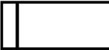Data Flow
4. Data Store

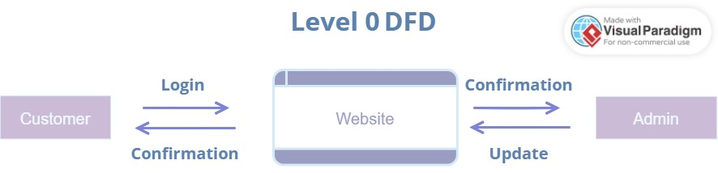**DFD on Flipkart**

**Level 1 DFD**

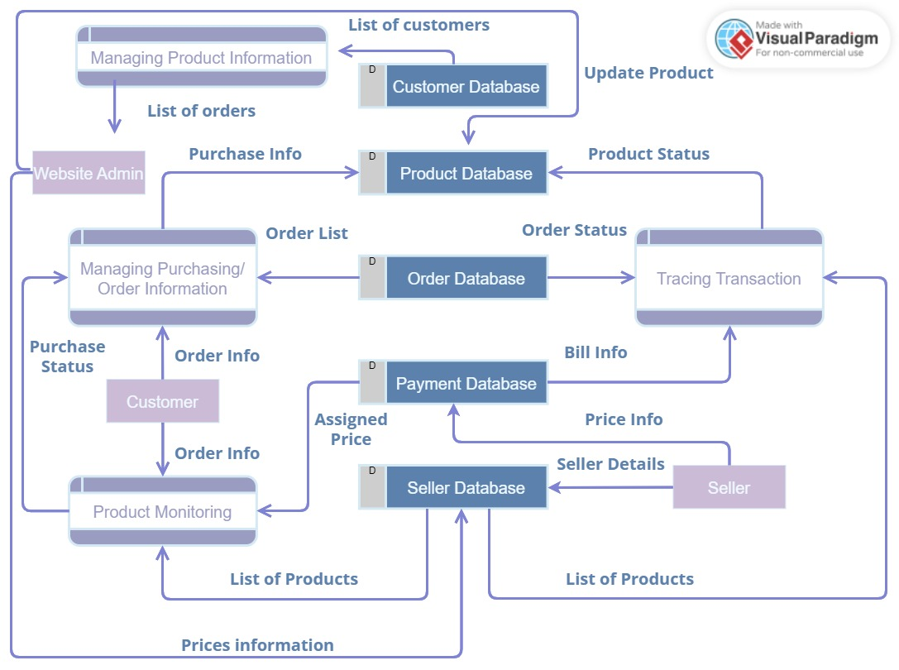

1. What is Flowchart? Create a flowchart to make addition of two numbers.

Ans. Flow chart is a diagrammatic representation of a process or algorithm. A flowchart uses numerous shapes as rectangles, ovals, diamonds to depict the type of step alongwith connecting arrows to define flow and sequence.

ALGORITHM: FLOWCHART:

**Step 1**: Start

INPUT NUMBER 1, NUMBER 2

PRINT SUM

SUM = Number 1 + Number 2

**Step 2**: Input number 1 and number 2

**Step 3**: Summation of number 1 and number 2

**Step 4**: Display Sum

**Step 5**: End

1. What is Use case diagram? Create a use case on bill payment on paytm.

Ans. A use case diagram depicts set of possible interactions between systems and users in a particular environment and related to a specific goal. It describes all the steps taken by users to complete the desired task.

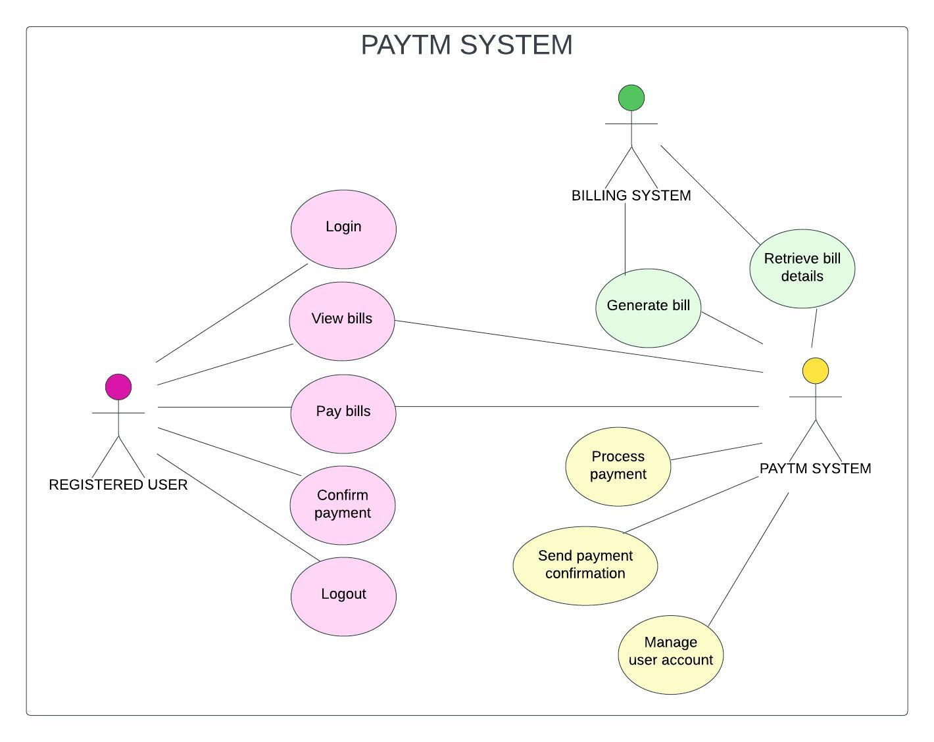**USE CASE DIAGRAM ON BILL PAYMENT ON PAYTM**